February 17, 2022

IMMEDIATE PRESS RELEASE

Kawasaki Announces All-New Dealer Marketing Application with the Kawasaki Social Video Creator

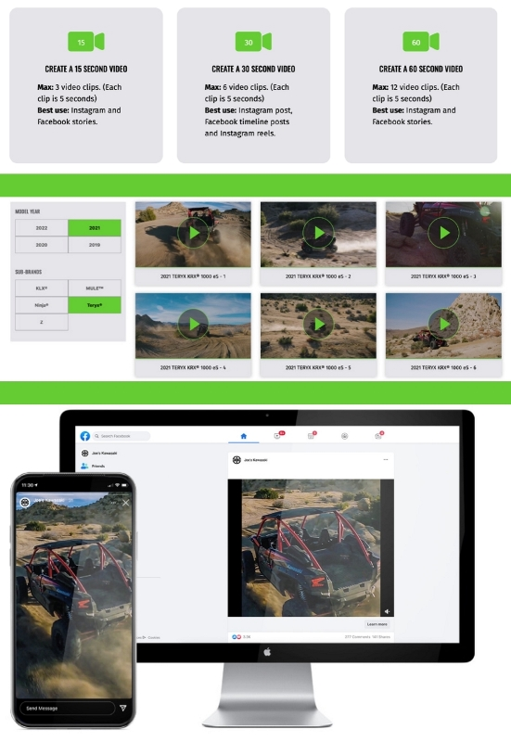
Foothill Ranch, Calif. – Kawasaki Motors Corp., U.S.A. is pleased to announce an all-new and innovative marketing application within its dealer marketing portal, the Kawasaki Social Video Creator. The Kawasaki Social Video Creator is an innovative tool allows Kawasaki dealers to select and stitch together running footage of Kawasaki’s powersports product lines into 15, 30, and 60-second video clips that can be uploaded to a dealer’s social media channel. This new concept will allow dealers to customize their social media content with high-quality footage of Kawasaki products.
“The introduction of the all-new Kawasaki Social Video Creator application allows our dealers to leverage all of the great video content we capture across all model segments. This is a truly innovative marketing tool and we’re proud to provide our dealerships with the tools needed to succeed,” said Kawasaki Motors Corp., U.S.A. Vice President, Marketing, Chris Brull.
The new Kawasaki Social Video Creator tool is designed to provide dealerships with a best-in-class marketing tool that allows them to create custom video content to promote based on the dealership’s marketing strategy. The Kawasaki Social Video Creator will give dealers the ability to create videos across Kawasaki segments and sub-brands; with an average of 10 video clips per model and more than 320 video clips in total, there is an endless combination of videos that can be created to support Kawasaki products.
Kawasaki Social Video Creator Features:
- Simple drag-and-drop user interface
- Optimized for desktop or mobile devices
- Ability to stitch together 15, 30, and 60-second clips from short 5-second clips
- Access to hundreds of video clips across sub-brands and model years
- A robust music library across genres – rock, pop, country, and more
- Ability to preview the video before exporting to ensure you have exactly what you want
- Export in 4:5, 9:16, or 16:9 aspect ratios to fit various social media platforms
The videos created through the Kawasaki Social Video Creator can be shared across social and digital platforms that include Facebook, Instagram, YouTube, or published directly to the dealer’s product pages on their website. Adding caption copy to each post to engage the customer and encourage them to visit their dealership can enrich the content.
Kawasaki is excited to continue to work closely with its independent dealer network providing innovative tools to further consumer engagement, excitement, and education.
ABOUT KAWASAKI
Kawasaki Heavy Industries, Ltd. (KHI) started full-scale production of motorcycles over a half century ago. The first Kawasaki motorcycle engine was designed based on technical know-how garnered from the development and production of aircraft engines, and Kawasaki’s entry into the motorcycle industry was driven by the company’s constant effort to develop new technologies. Numerous new Kawasaki models introduced over the years have helped shape the market, and in the process have created enduring legends based on their unique engineering, power, design and riding pleasure. In the future, Kawasaki's commitment to maintaining and furthering these strengths will surely give birth to new legends.
Kawasaki Motors Corp., U.S.A. (KMC) markets and distributes Kawasaki motorcycles, ATVs, side x sides, and JET SKI® watercraft through a network of approximately 1,100 independent retailers, with close to an additional 7,700 retailers specializing in general purpose engines. KMC and its affiliates employ nearly 3,100 people in the United States, with approximately 260 of them located at KMC's Foothill Ranch, California headquarters.
Kawasaki’s tagline, “Let the good times roll.®”, is recognized worldwide. The Kawasaki brand is synonymous with powerful, stylish and category-leading vehicles. Information about Kawasaki’s complete line of powersports products and Kawasaki affiliates can be found on the Internet at www.kawasaki.com.

